Name: ____________________________________ Date: ____________
American History Ms. Bongiorno
World War II
The End of the War in Europe
AIM: How did the War in Europe come to an end?
The Holocaust
- In the last months of the European war, Allied forces uncovered unimaginable horrors.
- The _________________________________________ was the systematic murder of 11 million people across Europe, more than half of whom were Jewish.
- The Holocaust was based on 3 key ideas:
1. _________________________________________-extreme hatred and prejudice toward Jews.
2. ________________________________________-to take away a person’s human qualities in order for them to seem less than human.
3. __________________________________________ - the deliberate killing of an entire group of people.
The End of War In Europe
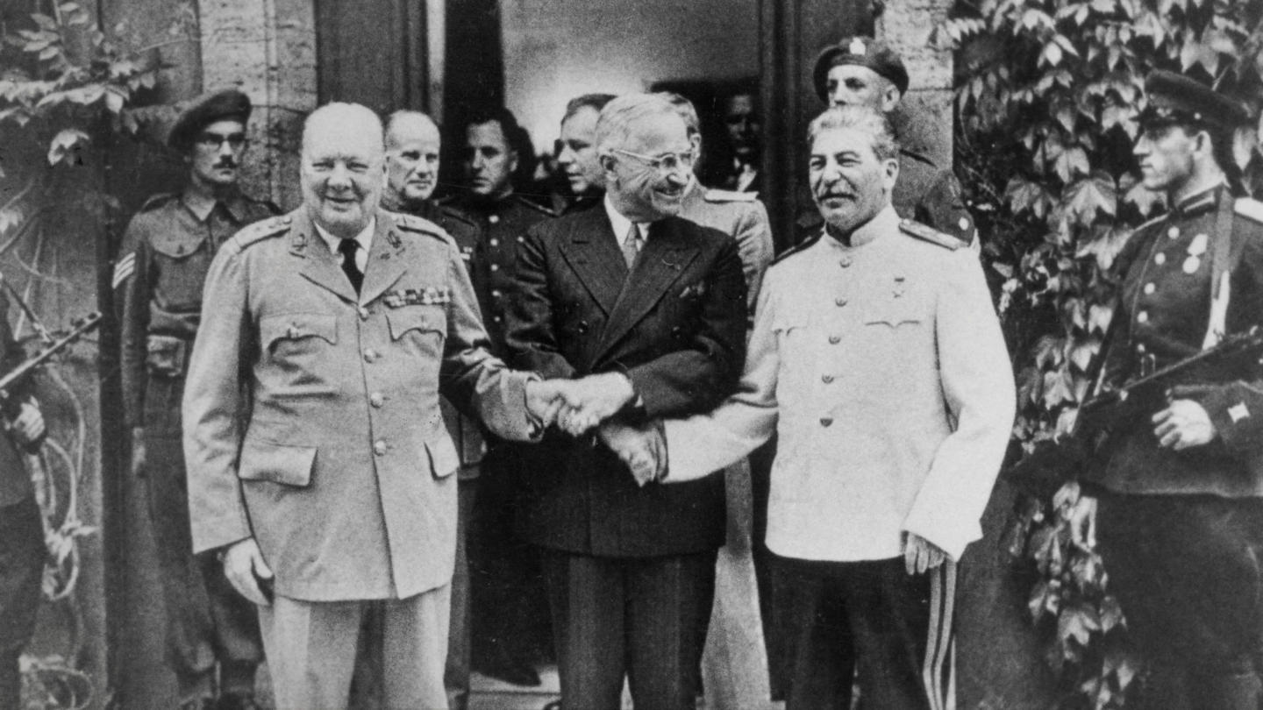
1. April 28, 1945- ____________________________________ captured by Italian underground, shot & hung upside down in Milan Square.
2. May 1, 1945-it was announced that _________________________ was dead. He and wife Eva Braun committed suicide.
3. ____________________________________- Victory in Europe Day, May 8, 1945. Gen. Eisenhower accepted unconditional surrender of Germany.
At Home in the United States
1.President _____________________________________________ ran for _____________________ in
____________________ and _________________.
2. In early April 1945 FDR had a stroke and _________________. He never saw the end of World War II.
3.Vice President __________________________________________ was faced with taking over a country in the midst of war.
“I felt like the moon, the stars, and all the planets had fallen on me,” he later recalled.

