**Military Aggression**

is a *warlike* act by one country against another *without cause*.

Station 1 [The Soviet Union](Russia.wmv)

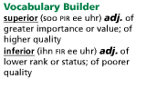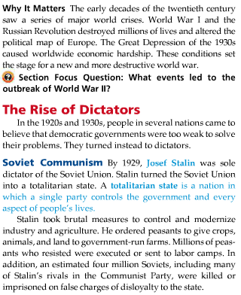

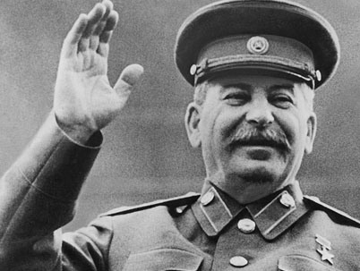 

Station 2 [Italy](Italy.wmv)

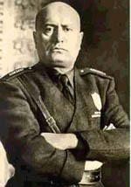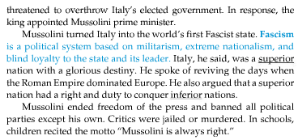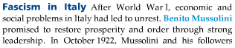

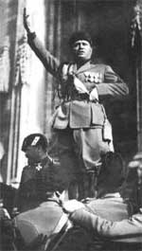

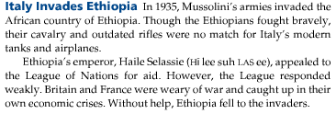

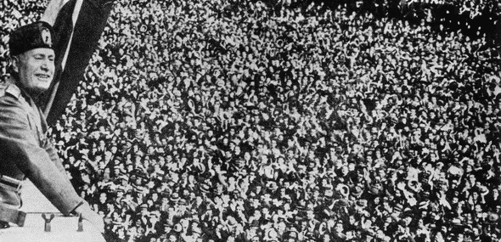

[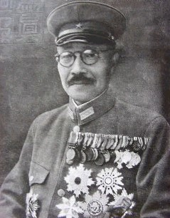](http://www.findagrave.com/cgi-bin/fg.cgi?page=pis&GRid=20880&PIgrid=20880&PIcrid=639698&PIpi=358669&)Station 3 [Japan](Japan.wmv)

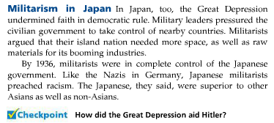  
 General, and eventual Prime Minister, Hideki Tojo created a Military Dictatorship,   
 which invaded Manchuria, parts of China and Indochina.

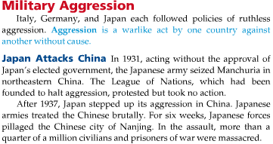

[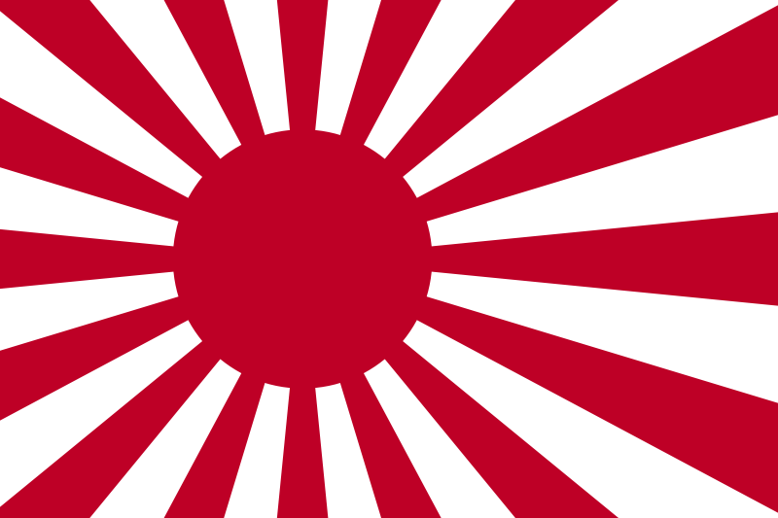](http://upload.wikimedia.org/wikipedia/commons/4/4f/Naval_Ensign_of_Japan.svg)

Station 4 [Germany](Germany.wmv)

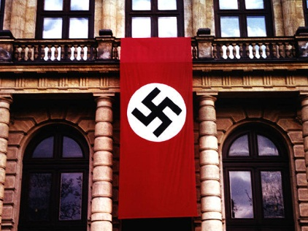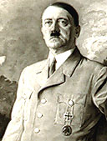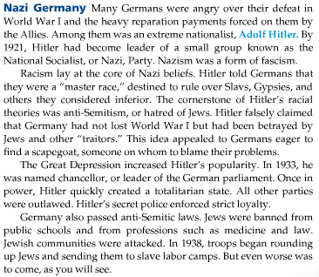 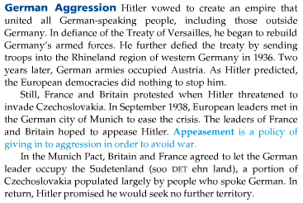

Station 5 [Appeasement](appeasement.wmv)



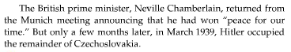

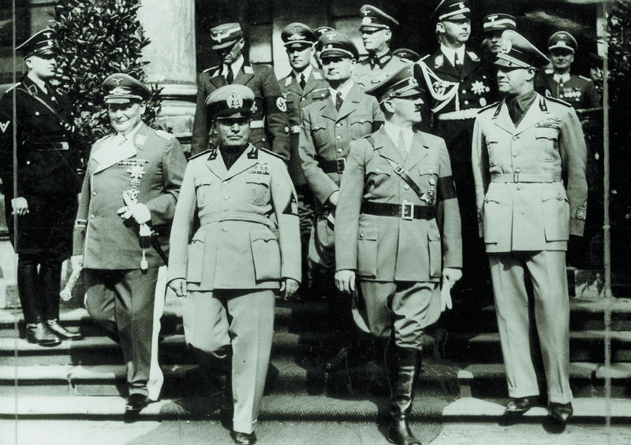 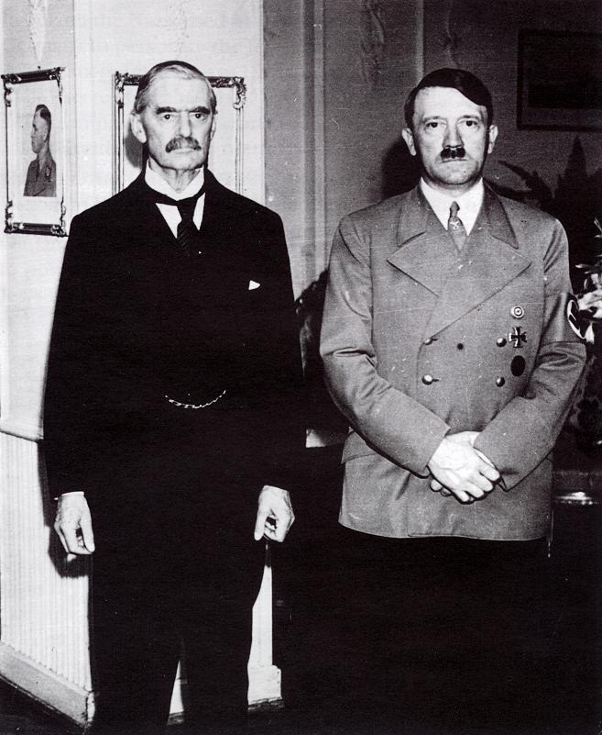  
 British Prime Minister Neville Chamberlain poses with Germany’s Adolf Hitler

Station 6 [American Neutrality](WWII%20intro.wmv)

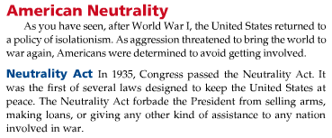

[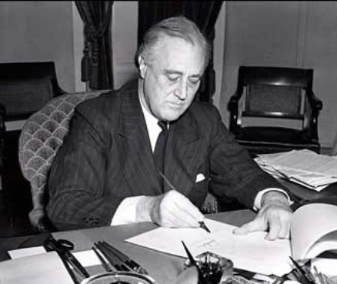](http://upload.wikimedia.org/wikipedia/commons/8/8d/President_Franklin_D._Roosevelt-1941.jpg)